PWA video 9 Service worker install event

<https://www.youtube.com/watch?v=JnCEXQo_TiI>

We can listen to/for this install event and do something with it.

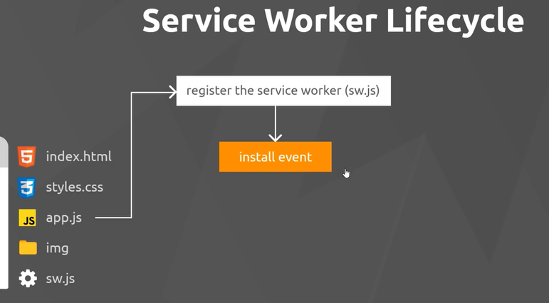

Do this from the service worker file itself

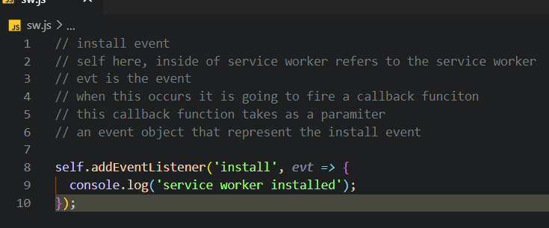

Now it is installed but not yet active in the browser that is the activated Event

